Assignment No. 2

blab-03@blab03-OptiPlex-5060:~/33373/WAD/Assignment 1$ git init
Initialized empty Git repository in /home/blab-03/33373/WAD/.git/

blab-03@blab03-OptiPlex-5060:~/33373/WAD/Assignment 1$ git config --global user.name "omiswami99"
blab-03@blab03-OptiPlex-5060:~/33373/WAD/Assignment 1$ git config --global user.name "Github@Omi09"

blab-03@blab03-OptiPlex-5060:~/33373/WAD/Assignment 1$ git remote add origin https://github.com/omiswami99/wad-assignment1.git

blab-03@blab03-OptiPlex-5060:~/33373/WAD/Assignment 1$ git add .
blab-03@blab03-OptiPlex-5060:~/33373/WAD/Assignment 1$ git commit -m "Assignment1"
[master (root-commit) c35c4fa] Assignment1
4 files changed, 228 insertions(+)
create mode 100644 img/dashboard.jpg
create mode 100644 img/map.jpg
create mode 100644 index.html
create mode 100644 style.css

blab-03@blab03-OptiPlex-5060:~/33373/WAD/Assignment 1$ git push -u origin main
Username for 'https://github.com': omiswami99
Password for 'https://omiswami99@github.com':
Enumerating objects: 7, done.
Counting objects: 100% (7/7), done.
Delta compression using up to 6 threads
Compressing objects: 100% (6/6), done.
Writing objects: 100% (7/7), 479.59 KiB | 20.85 MiB/s, done.
Total 7 (delta 0), reused 0 (delta 0)
To https://github.com/omiswami99/wad-assignment1.git
* [new branch] main -> main
Branch 'main' set up to track remote branch 'main' from 'origin'.

Screenshots:

Created Repository ‘WADL’:

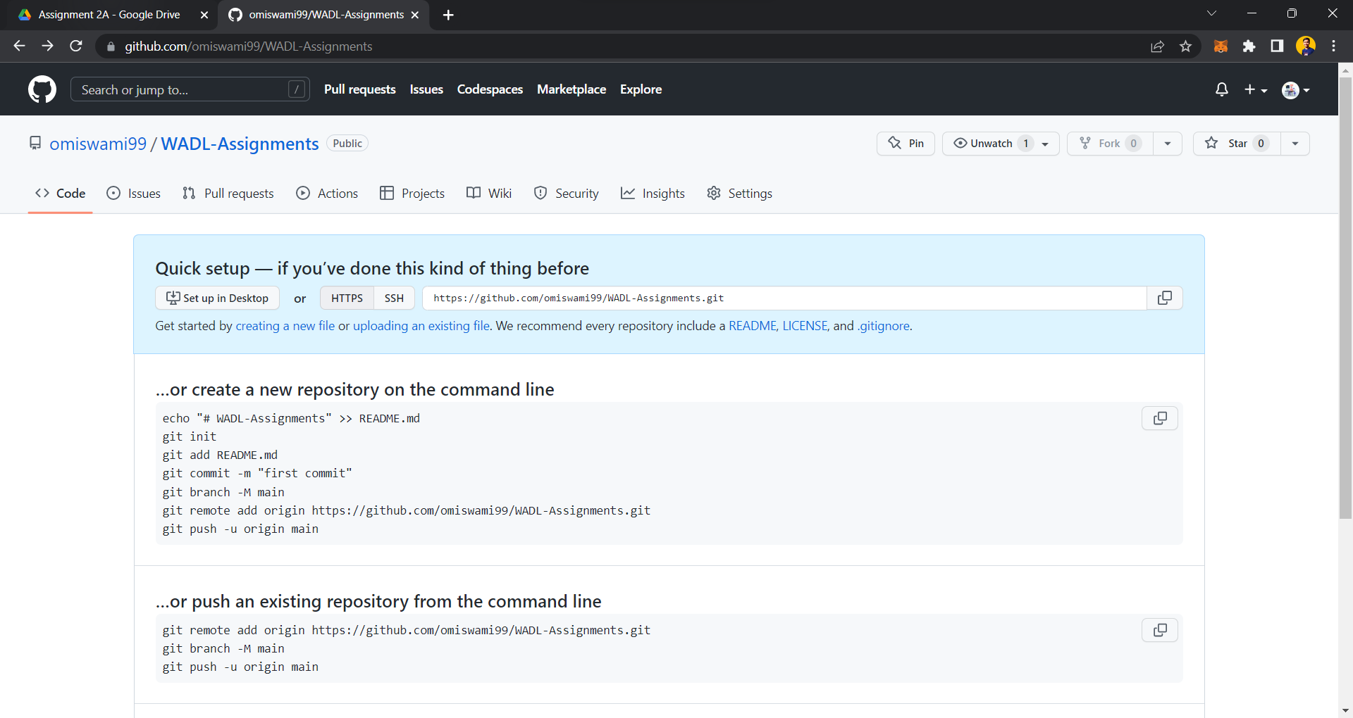

Pushed all the assignment folders:

